2.6 Mt. of Beatitudes
(Hebrew: Har Ha'osher)

Summary of the description of the Property and its history and development
New Testament reference:
The Sermon on the Mount (Matthew Chapters 5-7, Luke 6:17-49)
Significance
The Sermon on the Mount is widely regarded as one of the prime symbols of the ministry of Jesus. The sermon draws the fundamental teaching of the New Testament that is based on Beatitudes rather than commandments (as the Mosaic Law). The sermon lays the basis for the Christian perception of Charity, Piety and Grace.
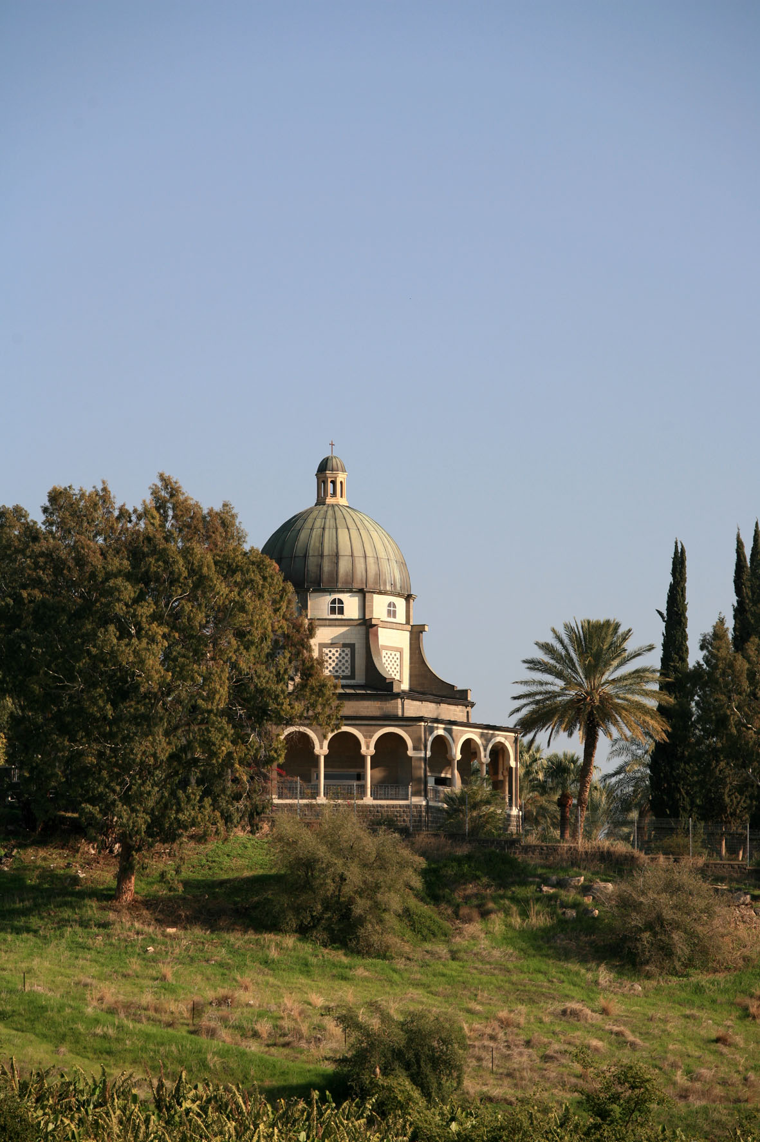
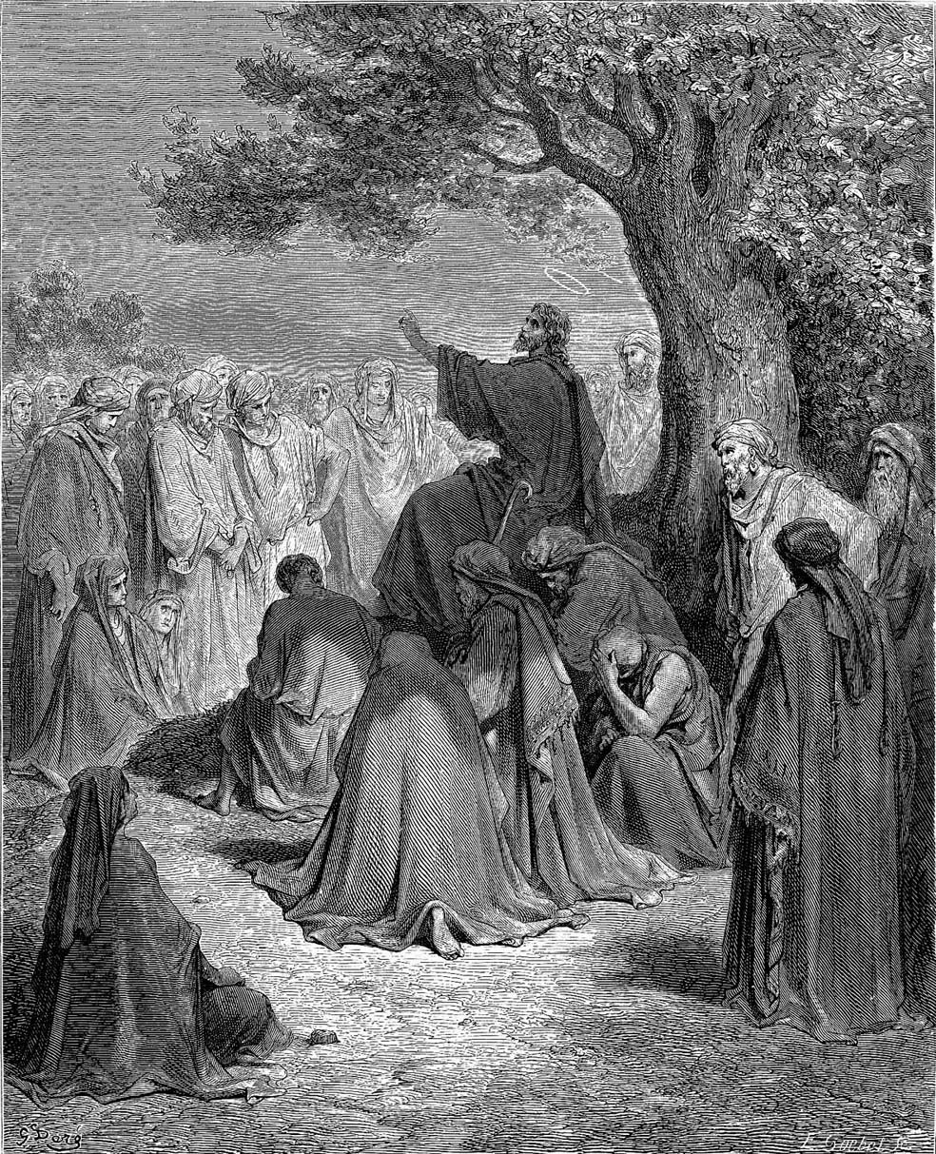
Since early Christianity, the north spur of the mountain was renowned haven for Christian pilgrimage. Early traditions located the place where "…He went up on a mountain, and when He was seated His disciples came to Him. Then He opened His mouth and taught them…" (Matthew 5:1-2) at the foot of the mountain where remains of a Byzantine chapel were excavated, or a bit further, on top of Mughara Ayub (Jobs cave) as described by Egeria: "On the hill which rises nearby is a grotto, upon which the Lord ascended when he taught the Beatitudes.". Today the event is commemorated by a modern octagonal chapel overlooking the north shore of the Sea of Galilee and the localities of the Galilean Ministry of Jesus.
Fig. 77. "Jesus Preaching to the Multitude" by Gustave Doré
Fig. 78. The Church of the Beatitudes from the south.
The scenery and the rural – agricultural nature of the landscape are associated with the countryside of the "sacred triangle" i.e. Capernaum, Tabgha and the Mt. of Beatitude, where major part of Jesus activity took place. References in the scriptures talk about the solitary place "Eremos topos" and "the mountain". Until today, the serene qualities of the site preserve its spiritual significance.
Description of Property
Memorial Church with concentric octagonal plan commemorating the eight passages of the Beatitudes; Hospice and pilgrim's guesthouse, pastoral gardens, panoramic view of the area of Jesus' ministry.

History and Development
1911: entrusted to the Franciscan Missionary Sisters of the Immaculate Heart of Mary; Sister's hospice
1936-1938: erection of the Church of the Beatitudes by the ANSMI
1964, 2000: visits of Pope Paul VI and Pope John Paul II

Detailed description of the Property and its history and development

Name and Identification
The Mt. of Beatitudes (meaning happiness, blessed joy) is the Latin name that refers to the 'mountain' on which Jesus delivered the Sermon of the Beatitudes (Matthew chaps. 5-7; also termed, since the late 4th century C.E., The 'Sermon on the Mount') whose first 8 passages begin with the word אשרי (Ashrei, Blessed joy; Mathew 5: 3-11). Thus in Hebrew the site is rendered הר האושר (Har Ha'osher). Today this name refers to the relatively modern site of the early 20th century Church of the Beatitudes, located on a spur ca. 1 km to the north-east of Tabgha (89 m' below sea level, c.a. 120 m' above the Sea of Galilee). This site, with commanding views of the Lake and of the historical Mt. of Beatitudes below, has been consecrated by the Catholic Church in memorial to the Sermon on the Mount and is today a major focal point for Christian Pilgrims (Fig. 77).
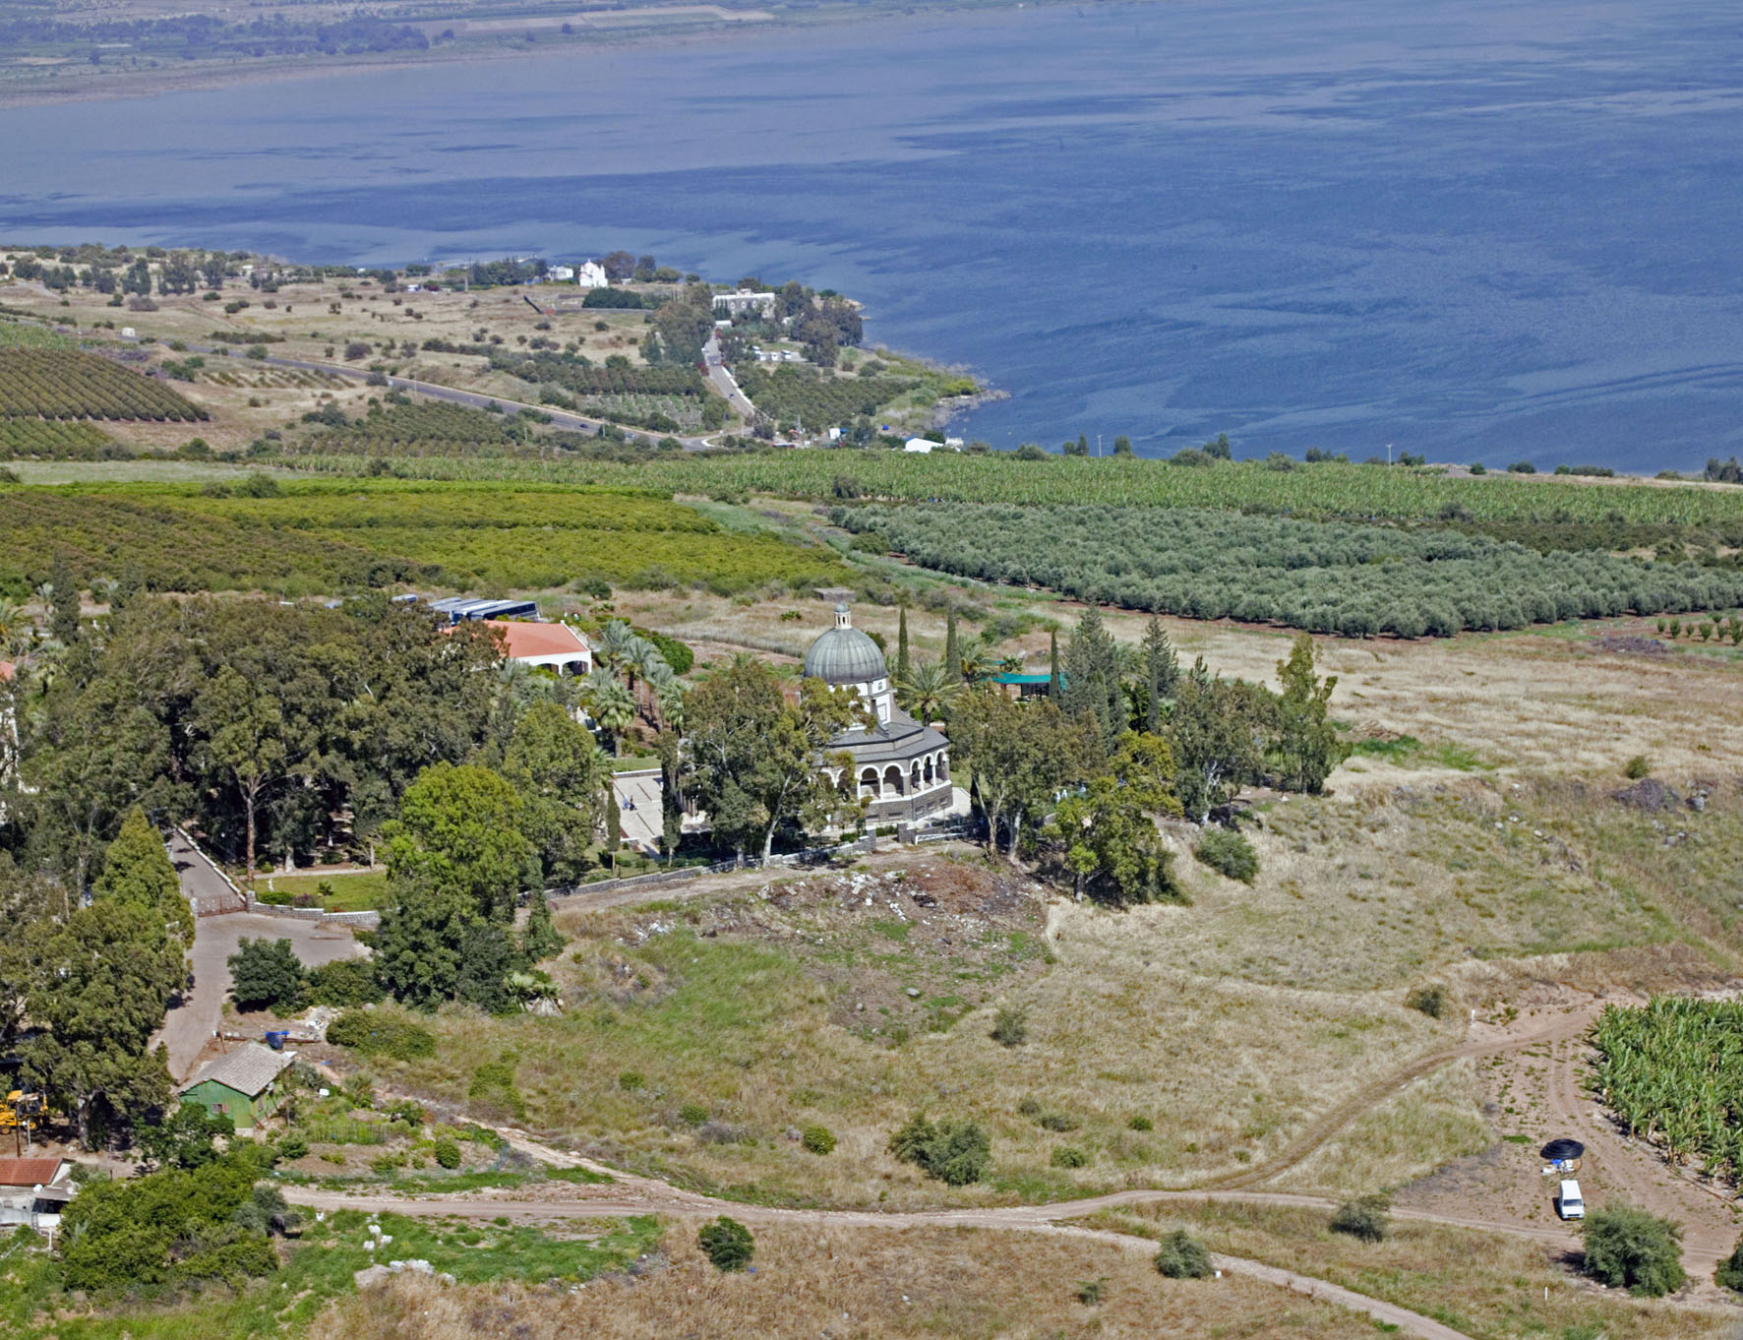
Fig. 79. Aerial Photo of the Mt. of Beatitudes looking eastwards to Capernaum and the Sea of Galilee.

Description of the Mt. of Beatitudes at the present time
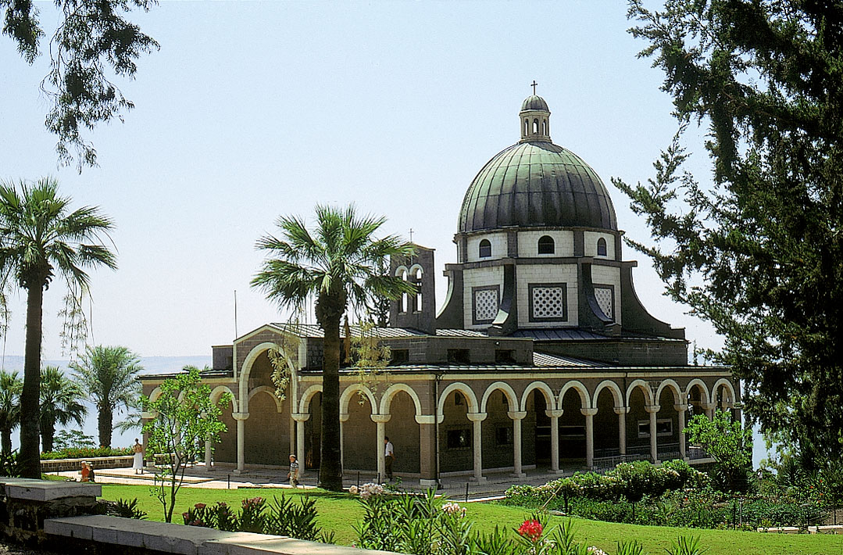
Access to the site by vehicle is via a 1 km long side-road leading from the main Tiberias - Rosh Pinna road. Entry is through a guarded gate, leading to a new parking lot adjacent to a one-story service building housing restrooms, a kiosk and souvenir shop. From here a path leads west towards the Church of the Beatitudes and its surrounding gardens (Fig. 81).
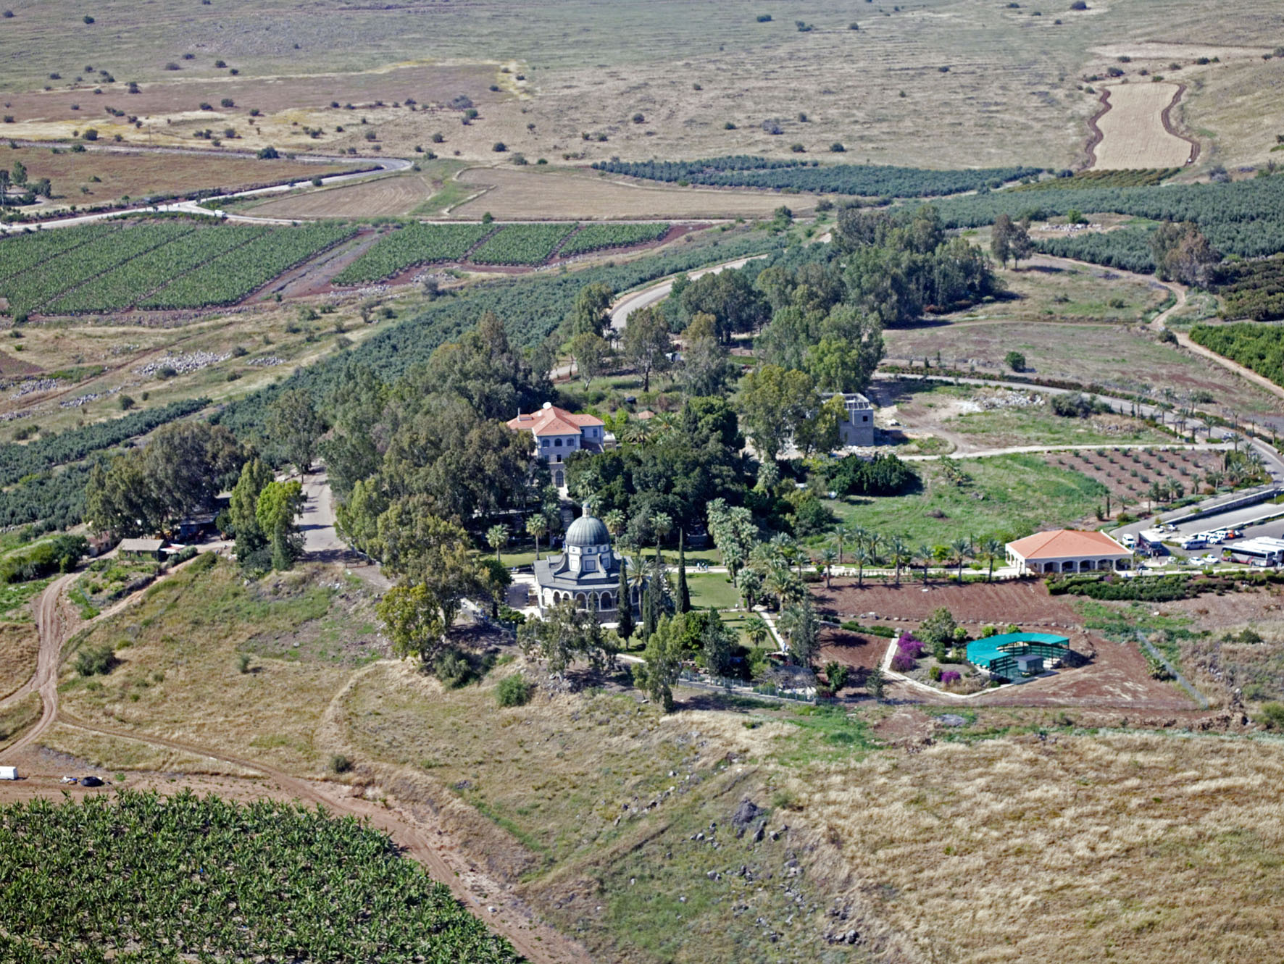
The Church: Inaugurated in 1938 and planned by the Italian architect Antonio Barluzzi, the building was designed as a relatively small memorial Church with a concentric octagonal plan commemorating the eight passages of the beatitudes (Matthew 5: 3-10) (Fig. 80). The building material used in construction includes local limestone and basalt stone, imported multi-colored Italian marble and metal-ware. Its distinct symbol is its raised dark-green copper dome, prominently seen from afar. The Church interior consists of a central hall featuring a raised altar, surrounded by inner and outer octagonal walls separated by a peripheral corridor. The upper part of the arched inner wall delineating the central hall is decorated with eight inscribed stained-glassed windows ornamented with the passages of the Beatitudes; the peripheral corridor is utilized for private and public prayer. The modern altar is made of imported Italian marble, decorated above with mural depictions of New Testament scenes and events. The inner side of the raised dome, projecting above the central hall, is sheeted with gold-tinted mosaics. The mosaic-tiled floor of the central hall features a wavy-water pattern symbolizing the Sea of Galilee, and eight ornamented inscribed tiles depicting the seven noble virtues of man and one declaring 'Blessed be the Lord'. On the building's outer side is a peripheral pillared porch, from where views encompassing much of Eastern Galilee may be obtained.
Fig. 80. Church of the Beatitudes from the north west.
Fig. 81. Aerial Photo of the Mt. of Beatitudes looking west, showing the cultivated plots and the dry hills at the back.
The compound and its environs: Surrounding the Church are pastoral gardens and paths leading to shaded prayer corners, while most of the compound in itself is covered by a small forest of planted trees (mainly Eucalypti and Sycamores) which stands out in the otherwise treeless landscape of the Corazim plateau. In the fields surrounding the compound there are several orchards of Olive trees, banana plantations and wheat fields (Fig. 81).
From the western outer side of the compound a path leads down to Tabgha, 1 k"m to the south, a popular pilgrim route (Fig. 82). The path at first passes via several huts and sheds (one used as living quarters for an Arab-Christian family, the others mostly for agricultural storage) and then byway the natural mildly-sloped basalt spur of the Historic Mt. of Beatitudes, on whose lower slope (overlooking Tabgha) should be located the original site of the Sermon on the Mount (see below). Although the Tabgha sites and valley cannot themselves be observed from the upper part of the spur (and neither from the Church itself), a fine general view of Sea of Galilee and its environs escorts the visitor on his way down, until finally reaching the lower slope of the hill overlooking the Tabgha valley and its holy sites.

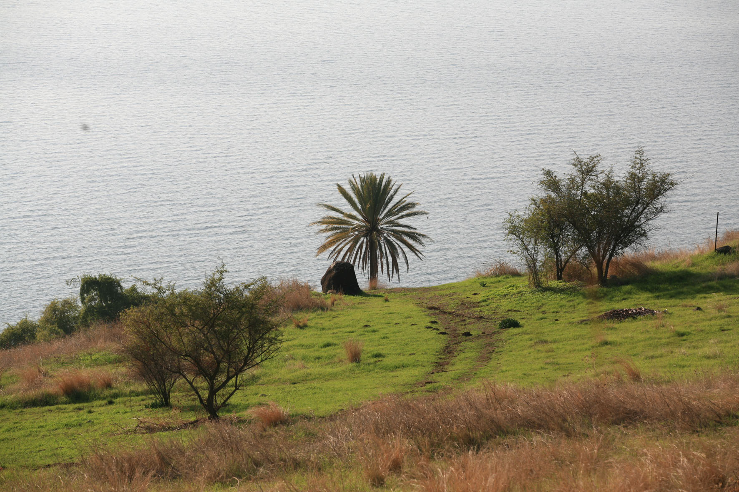
History and Development of the Mt. of Beatitudes
The present compound of the Mt. of Beatitudes was acquired at the beginning of the 20th century by The Associazione Nazionale Italiana Ernesto Schiapparelli (= National Association for Aid to Italian missionaries, ANSMI) and entrusted to the Franciscan Missionary Sisters of the Immaculate Heart of Mary in 1911, who erected a three-story Sister's hospice on the site (today the Pilgrim guest house north of the Church). In 1936-1938 the Church of the Beatitudes was erected by the ANSMI as a memorial to the Sermon on the Mount and as a focal point for modern Christian pilgrimage. Since then the site has been fostered with gardens and tree-shaded prayer corners, and the Sister's Hospice turned into a modern Guesthouse. In 1964 Pope Paul IV prayed here and read to the people the Beatitudes from the Gospel of Matthew; in the year 2000 the church was visited by Pope John Paul II. In 2004, a new parking lot was layed out and service building erected to the east of the church, easing the absorption of the thousands of visitors, mostly Christian pilgrims, to the site. A new Sister's hospice and an annex to the Pilgrim guest house are currently (2007) being constructed north of the service building.
Fig. 82. The natural landscape of the area along the pilgrims path going from the Mt. of Beatitude to Tabgha.

Bargil p37

